Deyesolar inverter - 5 great benefits with this device

Deye Solar Inverter is one of the guiding brands of residential solar power products on the market today. They are considered an innovator in the field of residential solar power generation. Their array inverters are manufactured using advanced computer controlled designs and tested over many years to deliver outstanding output.
The Deye Solar inverter monitoring system includes three-phase power conversion, total membrane venting and high frequency operation. It has all the necessary components such as battery pack, charge controller, fuse box, power busbar, terminal block, precision terminal block and fiber optic cables. All parts are made from the finest materials available to ensure max. performance and long life. All Deye solar generating units have been UL approved for outdoor and indoor use. All Deye Solar inverters come with a two-year warranty.
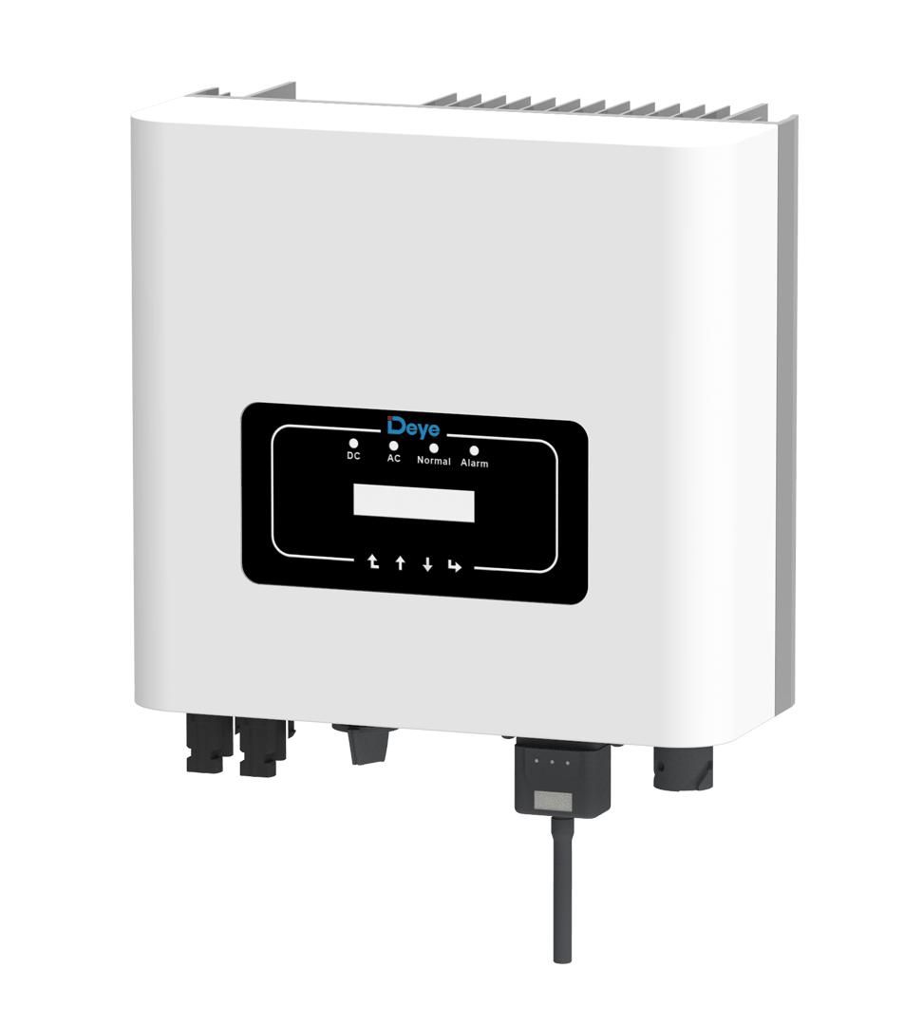
The 1st thing that users must know about this solar inverter monitoring device is its size. It is only 5 inches thick so it is compact and handy enough to carry without any difficulty. This makes it easier for users to install it on their terrace. It can help reduce the cost of energy production as it helps reduce the use of non-renewable resources.
Second, the remote monitoring system helps the user to monitor and measure the energy production. The device also helps users regulate the temperature and amount of sunlight for better solar energy use. Since solar energy is the primary source of energy needed by the home, this feature can reduce your bills. The remote monitoring system allows you to determine how much energy you are using and how much energy you need to generate from solar.
Third, the Deye solar indicator helps users to monitor and measure energy consumption. This is very beneficial for those who do not have a large budget for large solar systems. The unit has a built-in light that illuminates the energy collector when it is in use. It helps to reduce maintenance costs and makes the process faster and smoother. This reduces your bill and makes it more efficient. The unit is also small and does not generate any heat, which further reduces energy consumption.
Fourth, the monitoring system comes with a software that is easy to understand and follow. Users just need to download the program and install it on their computer. This helps you to monitor the system operation without any trouble. This is because the Deye Solar Indicator software contains all the features that you require. The software also guides the user through the process and gives them tips and tricks on how to use the device.
Fifth, the Deyesolar Inverter offers two modes to control energy production. These modes help manage solar power in the better possible way. It can be switched from high mode to low mode when solar power is low. This reduces your device's power consumption and saves you money.
The Deyesolar inverter provides enough power to run more electrical appliances in your home when you are not using a lot of energy from solar. This means you will be able to save on your electricity bills. Not only that, Deyesolar Inverter also helps generate more energy during the day to meet your electricity needs. It works well with batteries to generate more power than needed.

